
NORTHERN EDUCATION DIVISION
2026 JUNIOR CERTIFICATE MOCK EXAMINATION
CHEMISTRY
PROVISIONAL MARKING KEY (100 Marks)
Subject Number: J038
Wednesday, 09 April Time Allowed: 2 hours
8:00 – 10:0am

Question number | Tick if answered for Qs 21 to 30 | Do not write in these columns
1-20
21
22
23
24
25
26
27
28
29
30
31
32
33
Total
Instructions

- This paper contains 12 printed pages. Please check
- Write your Name on top of every page.
- Answer all the 33 questions.
- This paper contains section A, B and C.
- The use of scientific calculators is allowed.
- In the table provided on this page, tick against the question number you have answered.
- Hand in your paper to the invigilator when time is called to stop writing.

Turn over…

SECTION A (20 marks)
There are twenty questions in this section. Encircle the letter corresponding to the correct answer.

- Which branch of chemistry involves study of techniques that are used to find out about composition of matter?
- Environmental Chemistry
- Physical Chemistry
- Analytical Chemistry
- Industrial Chemistry
- Which of the following is a chemical symbol of element called Lead?
- Ca
- L
- Hg
- Pb
- Express 302.43 in scientific notation
- 302.43×10⁰
- 30.243×10²
- 3.0243×10²
- 3.0243×10⁻²
- Which of the following is general formula for alkanes?
- C_{n}H_{2n+2}
- C_{n}H_{2n+1}
- C_{n}H_{2n}
- C_{n}H_{2n}OH
- Which of the following bonds involves sharing of valency electrons?
- Electrostatic bond
- Covalent bond
- Metallic bond
- Ionic bond
- Which of the following gases support combustion?
- Oxygen
- Hydrogen
- Carbon dioxide
- Sulphur dioxide
Figure 1 is a diagram showing a technique used for separating mixtures.
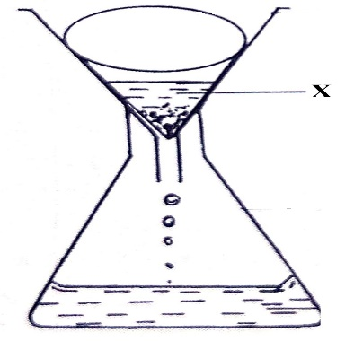
- State the method of separating mixtures indicated in the diagram
- Filtration
- Decantation
- Evaporation
- Distillation
- Which of the following is an example of mixtures that can be separated by the technique?
- Sand and petrol
- Oil and water
- Ink dye
- Iron fillings and sand
- Name the part labelled X
- Residues
- Distillate
- Water
- Filtrate
- What is percentage composition by mass of sodium in Na₂CO₃?
(RAM Na=23, C=12, O=16)
- 11.32%
- 15.09%
- 43.40%
- 45.28%
- Which pair has equal numbers of neutrons?
- ${}_{6}^{12}c∧{}_{12}^{24}{Mg}$
- ${}_{8}^{18}O∧{}_{9}^{19}F$
- ${}_{11}^{23}{Na}∧{}_{10}^{20}{Ne}$
- ${}_{8}^{17}O∧{}_{6}^{14}C$
- . Which of the following is not true about physical changes?
- difficult to reverse
- No new substance is formed
- The reactions are accompanied by great heat changes
- The reactants and products are in the same mass.
- Table 1 shows elements U, V, W and X found in the periodic table. Use the information to answer questions that follow.
Element | Atomic number | Mass number | Electron arrangement
U | 8 | 18 | 2,6
V | 18 | 40 | 2,8,8
W | 9 | 19 | 2,7
X | 3 | 7 | 2,1

- Which element is a halogen
- X
- U
- W
- V
- Which two elements would form an ionic bond?
- U and V
- U and X
- W and X
- V and W
- Which element is stable from the table
- U
- W
- V
- X
- Reactivity of Group VII elements decreases
- up the group
- down the group
- as the number of energy levels increases
- as the number of protons increases
- Which are the correct products for these reactants HCl + NaOH
- NaOH + H₂O
- HCl + H₂O
- NaCl + H₂O
- H₂O + NaO
- Which of the following properties is common to both acids and bases?
- having a sour taste
- having a low pH
- facilitating corrosion
- turning red litmus paper to blue
- The higher the cation exchange capacity of the soil the:
- Lower the soil fertility
- higher the soil fertility
- higher the water content of the soil
- Higher the production of carbon dioxide when the soil is heated

SECTION B (50 marks)
Answer all questions in this section in spaces provided
- a. Define ‘precision’
- precision is the closeness of experimental values to each other (1) (1 mark)
or how close measured values are close to each other

b. Table 2 shows results of volume of hydrochloric acid used to be neutralized by sodium hydroxide. The student found the following results upon repeating the experiment 4 times
Run | Volume of HCl used (cm³)
1st reading | 20.87
2nd reading | 20.41
3rd reading | 20.89
4th reading | 21.0
  - Which readings are precise? (3 marks)
First read (20.87 cm³), second reading (20.89 cm³) and third reading (21.0cm³)
  - Explain your answer in (i)
The mentioned values are close to one another (1). hence they are precise. (1) (2 marks)
  - If the actual value is 20.3 cm³ which value is the most accurate?
Second reading (20.41 cm³) (1) (1 mark)
- Figure 2 is an apparatus used in a chemistry laboratory
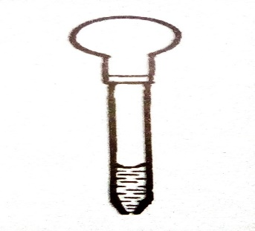
- Name the apparatus.
- A dropper (1)
- State one use of the apparatus
- Used for adding one substance to another drop by drop (1)

- Name instrument used to measure volume accurately in the laboratory
- Volumetric flask
- Pipette 1 mark for any
- a. Define the term electronegativity
- The ability of an atom to attract electrons towards itself (1)/ (1 mark)
b. Explain why atomic radius of elements increases down the group in the periodic table
- Going down the group atomic number increases(1)/this leads to the increases of number shells(1)/hence atomic radius increases(1)/ (3marks)
c. How many atoms are in Cu(NO₃)₂
- 9 atoms (1 mark)
- Figure 3 below shows a phenomena that happens in some states of matter.
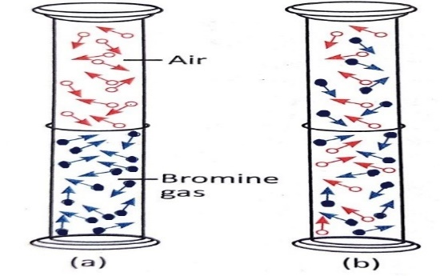
- Explain the phenomena illustrated by the diagram above?
The phenomena portrayed in the diagram above is called diffusion (1). It involves movement of bromine gas particles from a region of higher concentration (the lower test tube) to a region of lower concentration (test tube containing air). (1)
- In which state of matter is the phenomenon possible?
Liquids (1)
Gases (1) Any one
- Explain your answer in 10 a. (ii).
Because in liquids and gases particles are able to move (1) hence necessitating movement of particles from one point to another unlike in solids where particles are fixed. (1)

- A certain element in the periodic table above is denoted as ${}_{14}^{28}X$
- To which group of the periodic table does X belong? Give a reason for your answer.
- Electronic arrangement = 2,8,4 (1)
- Thus element X belongs to group IV (1)
- Since it has 4 electrons in the outermost energy level (1)
b. Identify element X in the periodic table.
- Silicon (1)
c. Write the chemical formula of the compound between Al and O.
- Al₂O₃ (1)
d. What type of bond exist between Al and O atoms? Give a reason for your answer?
- The type of bond between Al and O is ionic bond (1),
- Since Al lose outermost electrons that are gained by O atoms (1)
- a. State any one differences between physical and chemical changes
- In a physical change no new substance is formed whilst in a chemical change new substances are formed (1)
- Physical changes are reversible whilst chemical changes are difficult to reverse (1)
- Physical change mass do not change while chemical change mass changes
- Physical change no energy is given out or absorbed while chemical change energy is given out or absorbed
Any of the above
b. The reaction between magnesium and chlorine is represented by the following equation:
Mg (s) + Cl₂ (g) MgCl₂ (aq)
(RAM: Mg = 24, Cl = 35.5)

- Calculate the total mass of reactants (2 marks)
Total mass of reactants = RAM (Mg) + 2 ×RAM (Cl)

= (24 +2(35.5)) amu
= ( 24 +71) amu (1)
= 95 amu (1)

- Calculate the total mass of the product.
Total mass of products = RAM (Mg +2×RAM (Cl)
= (24 + 2(35.5) amu
= (24+71)amu (1)
= 95 amu (1)
- Establish the relationship between the total mass of reactants and that of the product.
- The total mass of reactants is equal to the total mass of products (1)
- What do you call the relationship established above?
- Law of conservation of mass (1)
- a. Define ‘Neutralization reactions’
This is a reaction between a between an acid and a base to produce salt and water. (1)
b. Explain one applications of neutralisation reaction?
Used in treatment of acidic soils by applying calcium hydroxide (lime) which neutralize the base (1)

- An alkene has 10 hydrogen atoms.
- Find the total number of carbon atoms?
General formula of alkenes = C_{n}H_{2n}
From the general formula the number of hydrogen atoms is given by 2n, thus
2n = 10 (1)
n = 10/2
n= 5 (1)

- Write molecular formula of the alkene.
- Molecular formula = C₅H₁₀ (1)
- Draw the structure of the alkene in 20.b. (ii).
(2 marks)
- a. State one use of the following gases.
- Carbon dioxide
- Used for preserving soft drinks and beer (1)
- Used by plants during the process of photosynthesis (1)
- Nitrogen gas
- Used in the transportation of crude oil, it is put in fuel tankers to prevent oxygen from reacting with crude oil and cause fire. (1)
- food preservation, nitrogen is pumped in most packed food to prevent oxygen from reacting with hence going bad (1)
b. Give one natural sources of Organic compounds (1 mark)
- Plants and animals
- Natural gas
- Coal
- Petroleum/crude oil 1mark for any correct option.

- a. Define the term soil salinity
- accumulation of salts in the soil. (1mark)
b. Explain two causes of soil salinity.
- low rainfall (1)/as water evaporates salts remain in the soi(1)l.
- poor drainage(1)/ water lodged leads to build up of salt(1).
- irrigating using poor quality water (1)/poor quality water contains salts that accumulate in the soil.(1)
- application of inorganic fertilizer (1)/ these contains salts that builds up in the soil(1). Any two 1 mark point, 1 mark supporting (4marks)

SECTION C (30 marks)
Answer all the questions in this section in the spaces provided.
- With the aid of a well labelled diagram, describe changes that candle wax undergoes when heated.
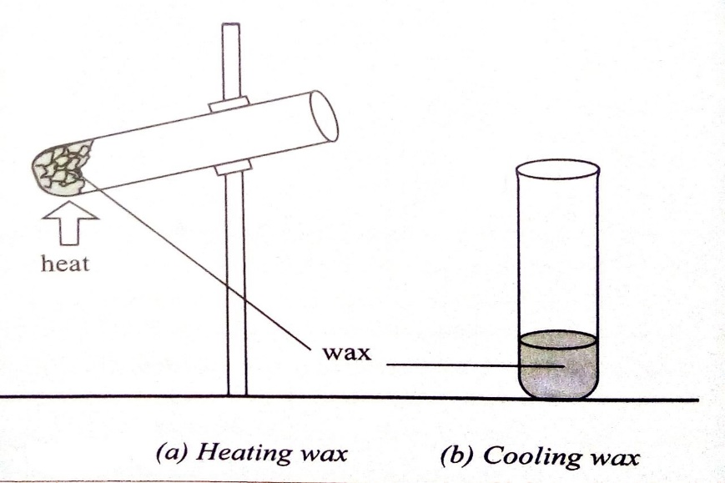2 marks for 2 diagrams, 1 for labelling
- Place pieces of candle wax in a test tube(1)
- Hold the test tube with test tube holder(1)
- Heat the test tube(1)
- Allow it to cool after heating(1)
- When candle wax is heated, it melts. (1)
- On cooling, it solidifies to form the solid wax again (1)
- Therefore the change is physical change(1) (10 marks)

- Describe an experiment that can be done to separate the mixture of iron nails, salt and sand
- Use magnet (1) / to attract and separate iron nails from the mixture (1)/
- move the magnet over the mixture (1) /
- the iron nails will be attracted (1)/.
- add water to the remaining mixture and stir until salts dissolves (1)/
- put the filter paper on top of the funnel (1)/
- pour the mixture through the filter paper into the beaker (1)/the sand will remain on the filter paper (1) /.
- heat the salt water solution using basin burner (1)/as water evaporates salt crystals will remain in the beaker (1). (10 marks)
- a. Describe how you would determine strength of an acid using universal indicator (5 marks)
- Put about 1 cm³ of the acid to be tested in a test tube (1)
- Add 2-3 drops of universal indicator into the test tube (1)
- Compare the colour of the solution with the colours on the pH scale chart and the pH values (1)
- Record pH value of the acid as compared on the indicator chart (1)
- If pH values ranges from 1 to 3.5 then it is strong acid and if pH values ranges from 3.5 to 6.5 then its weak acid or if the colour is red then it is strong and if colour is orange/yellow then it is weak acid (1)
b. Describe an experiment that can be done to distinguish pentane from pentene.
- Take two test tube (1)/ add pentane to one and pentene in the other test tube(1)
- Add few drops of Bromine solution to each test tube (1)
- Test tube which contain pentene and bromine solution will decolorize/change colour/turn colourless (1)
- Test tube contain pentane the colour will remain brown/unchanged (1)
- END OF PROVISIONAL MARKING KEY

